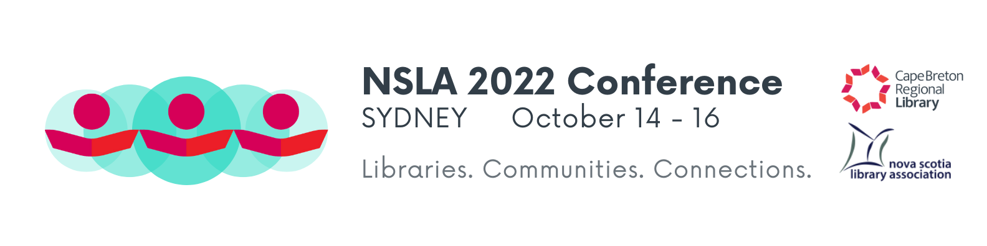
Registration Form

Name: _________________________________________ Phone: _______________________

Library/Organization: ____________________________________________________________

Address: ______________________________________________________________________

Postal Code: __________________________ Email: __________________________________

Conference Fees (fees do not include accommodations):
 |  |  | Early Bird  Sept. 14th |  | After Sept. 14th
Full Conference | Members |  | $175 |  | $185
(incl. Friday night Meet & Greet, breakfasts and lunch, nutrition break and banquet) | Non Members |  | $200 |  | $210
Pre-Conference Only |  |  | $25 |  | $25
Saturday Workshops | Members |  | $100 |  | $110
(includes nutrition break, Saturday breakfast and lunch, and banquet) | Non Members |  | $110 |  | $120
Additional Banquet Tickets | $45

Total Fee $___________

Please indicate if you have any dietary restrictions: _______________________________

Payment
Make cheques payable to NSLA Conference 2022
Mail to:
Tracy Wilson
NSLA Conference Convenor
Cape Breton Regional Library
50 Falmouth St.
Sydney, NS B1P 6X9

Forms and any questions can be sent to conference@nsla.ns.ca
Please indicate which sessions you plan to attend. **Note: Registration is limited for some sessions.

Name: ________________________________________
Friday, October 14
- 1:00 - 3:30pm Preconference Session 1: It Takes a Community to Create a Guideline
- 1:00 – 4:00pm Preconference Session 2: Connecting Communities to Medical Information: Bridging the Medical Information Gap.
- 4:30 – 6:30pm NSLA Board of Directors Meeting
- 4:30 – 6:30pm LBANS Executive Meeting
- 7:30 - 9:30pm Meet and Greet Reception

Saturday, October 15
- 7:00 – 8:00am Downtown Walking Tour

Breakfast 7:00-9:00
9:30 - 10:30am Official Opening/Keynote Address by Mary Beth Doucette

Session I - 11:00am - 12:00pm
- Object Lending – the good, the bad, the guitar
- Developing Library Staff to Foster Community and Connections
- Nova Scotia Provincial Library Cataloguing: updates and roundtable discussion
- Creating and Sustaining Community Memories

Session II – 12:00 - 1:00pm
- Meet People Where They Are
- Escape Rooms: Opportunities for Library Awareness and Fundraising
- Gender Affirming Products – A little bit of yarn and a whole lot of community
12:00 - 1:30
- Talking Sticks and Mi’kmaq Knowledge Sharing**

Lunch 1:00 - 2:30pm Exhibit Hall

Session III - 2:30-3:30pm
- Identity Crisis: Interregional Panel on Websites and Rebranding
- Not Just Drag Queen Storytime: Anticipate, Welcome and Celebrate 2SLGBTQIA+
- Books: We’re In It Together
2:30 – 4:00pm
- Self-Exploration through Paint at the Library**
Pre-dinner Meet & Greet 6:30-7:00pm
- Banquet 7:00-9:00pm

Sunday, October 16
Breakfast 7:30-9:30
8:00 - 9:30 NSLA Annual General Meeting
8:00 - 9:30 LBANS Annual General Meeting
Session IV – 9:30-10:30am
- Engaging & Celebrating African Nova Scotia Communities
- Resilient Together: Building School and Public Library Partnerships
- How to Communicate Your Library’s Value Through Earned Media

